Kade Samson

Seattle Pacific University

BS in CS 2024

Software Development

Westy – 2021-2023 - <https://github.com/kadealicious/Westy>

This project is a deferred rendering engine that I wrote entirely in C, using OpenGL, CGLM, GLFW, GLEW, & FreeType. The engine was originally written using the Windows-default HWND windowing system and CGLM for linear algebra operations, with graphics being done by pixel blitting on the CPU. I am currently rewriting the engine yet again to use Vulkan for improved performance and more control over the entire rendering pipeline (still entirely in C).

Version 1 (No Graphics Library): Version 2 (OpenGL):

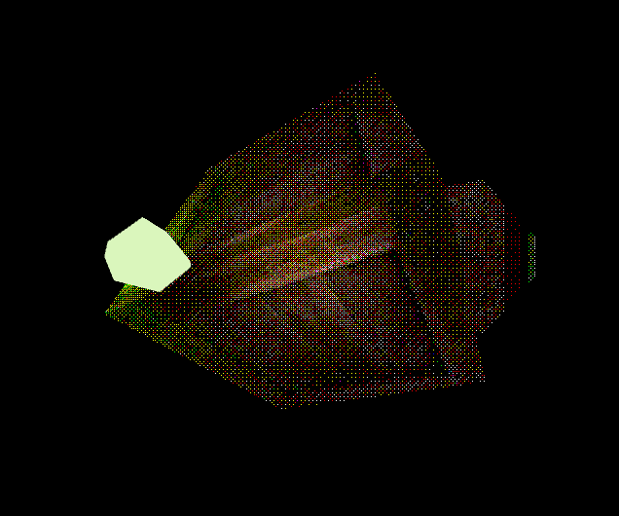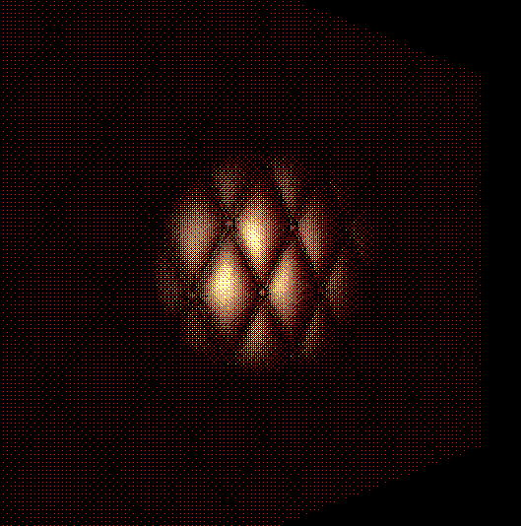

Web Design

JS Popup – 2021 - <https://github.com/kadealicious/JS-Popup>

This script is used to create an unintrusive popup element in an HTML document. The design goal here was to create a popup element that, A: Didn’t bloat the section of code it was applied to within the HTML document and, B: Was easily customizable and felt natural to use. I am very satisfied with how this project came out!

College Radio – July 2021 – <http://collegeradioband.com/>

College Radio is a musical act from Seattle, Washington, who asked me to build them a single-page site to promote their latest single at the time. The site I delivered was developed within a month and had a (nearly) perfect Lighthouse score.

Kustom Kulture Festival – April 2018 - <https://www.kustomkulturefestival.com/>

The Kustom Kulture Festival was a car show/Rockabilly music festival that continued from 2009-2018. During its final year of operation, I was tasked with building a comprehensive website within 2 weeks. The site needed to include a payment page for vendors and attendees, as well as a blog.

Audio Engineering

Dusty Cubby – 2018-2023 - <https://dustycubby.bandcamp.com/>

I have been recording and producing with this group for some time now. All recordings produced after 2020 were done by my friend Cade and me (we have the same birthday too).

College Radio – July 2022 – <https://collegeradioband.bandcamp.com/>

I assisted in the recording & production of this group’s latest release: “Nothing Ever Changes, it Only Gets Worse”. I have also helped the group record and produce some of their unreleased demos, with quick turnaround time.

Thank you for your time!

-Kade